  
  
**APP DEV**  
**FORMAN CHRISTIAN COLLEGE**

**Waleed Khalid 231476819**

**Umar Javed 241546728**  
**Aliza Khokar 241547622**  
  
  
**Cabify App**

**1. Overview:**   
  
Cabify stands as a robust transportation solution, offering a dual-service platform that seamlessly integrates ride-hailing and car rental functionalities. This app is designed to cater to diverse user needs, providing a reliable and convenient interface for both immediate travel requirements and extended vehicle rentals.

**2. App Scope:**

**Ride Booking:**

Real-time tracking for users to monitor the movement of their assigned vehicle.

Estimated time of arrival (ETA) feature to inform users of their driver's arrival time.

**Car Rental:**

Diverse fleet options including economic, standard, and luxury cars for daily, weekly, or monthly rentals.

Transparent pricing structure with clear terms and optional insurance choices.

**Driver Information:**

Detailed driver profiles with names, ratings, and contact information.

Enhances user trust and safety by providing insight into the driver's background.

**Payment Flexibility:**

Integration of multiple payment methods, including credit/debit cards and digital wallets.

Secure payment gateway ensuring the safety of users' financial information.

**Ride Scheduling:**

Advanced scheduling feature allowing users to plan and secure rides for future dates and times.

Option to confirm, edit, or cancel scheduled rides.

Screens & Functionality:

a. Sign-Up Page: - User-friendly account creation with the option for manual input or quick sign-up through social media accounts. - Ensures a smooth onboarding process for new users.  
  
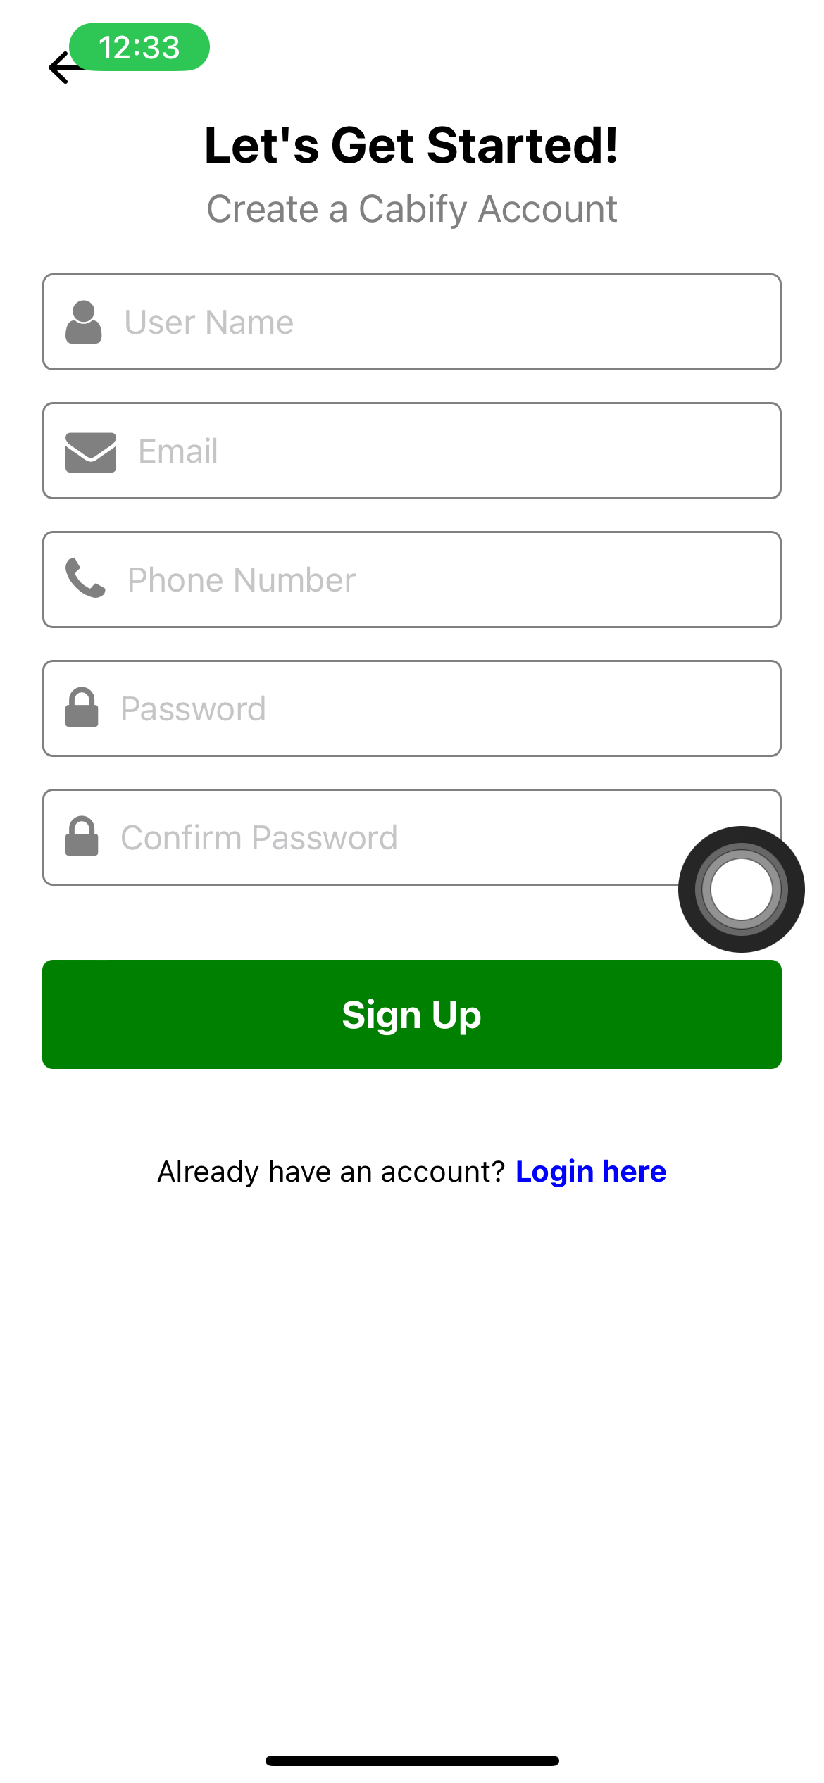

b. Ride Selection Screen: - User-friendly interface displaying ride types (daily, rental, outstation). - Map integration for destination selection with search functionality. - Real-time view of available ride options with vehicle details.  
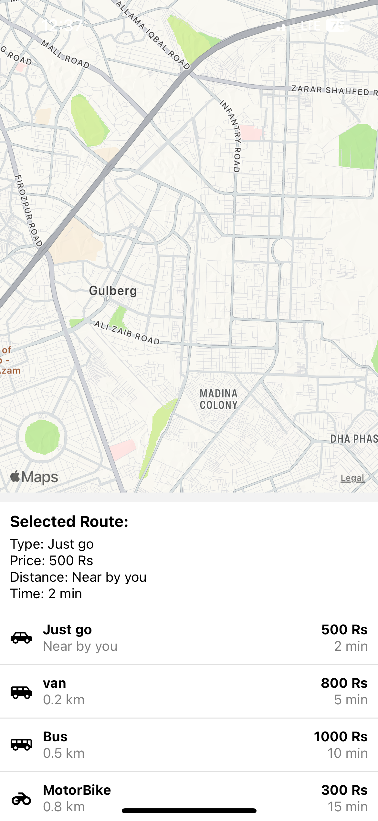

c. Ride Booking Details: - Detailed view of the selected ride, including the route on a map. - Display of driver information such as name, rating, and contact details. - Fare breakdown and an option to cancel the ride if needed.

d. Payment Method Selection: - Multiple payment options including credit/debit cards and digital wallets. - Secure gateway for entering and saving card details.  


e. Car Selection for Rental: - Comprehensive list of available rental cars with images, model names, and pricing details. - User-friendly interface allowing easy selection based on preferences and budget.

f. Schedule a Ride Screen: - Intuitive scheduling interface allowing users to set the date, time, and other ride preferences. - Confirmation feature and visibility of upcoming scheduled rides.

**4. Rental of Cars:**

In-depth fleet options catering to various user preferences and needs.

Transparent pricing, with a streamlined rental process for user convenience.  
  
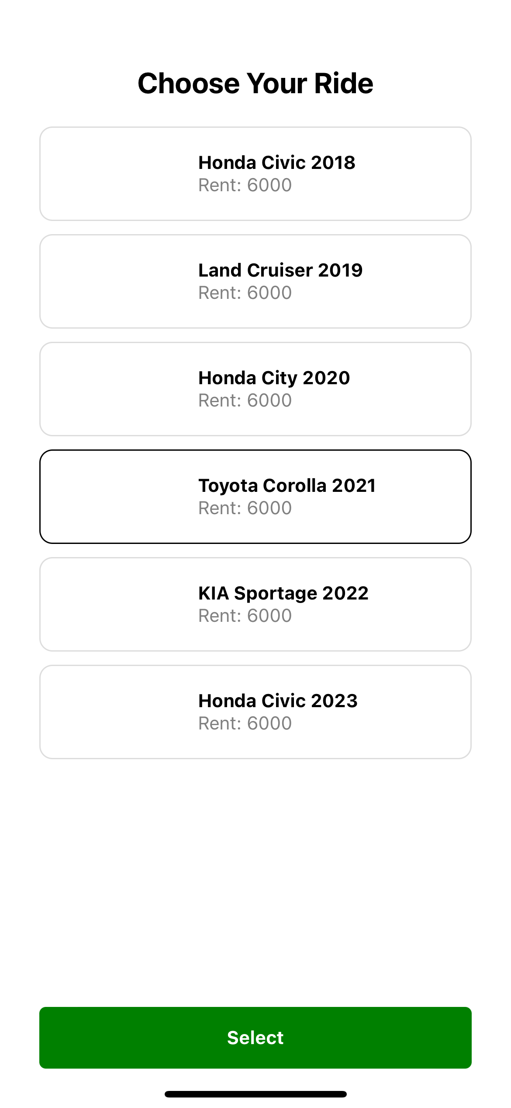

**5. Ride Scheduling:**

Advanced scheduling functionality for users to plan and schedule rides ahead of time.

Specify pick-up and drop-off locations, ride type, and set date and time.  
  
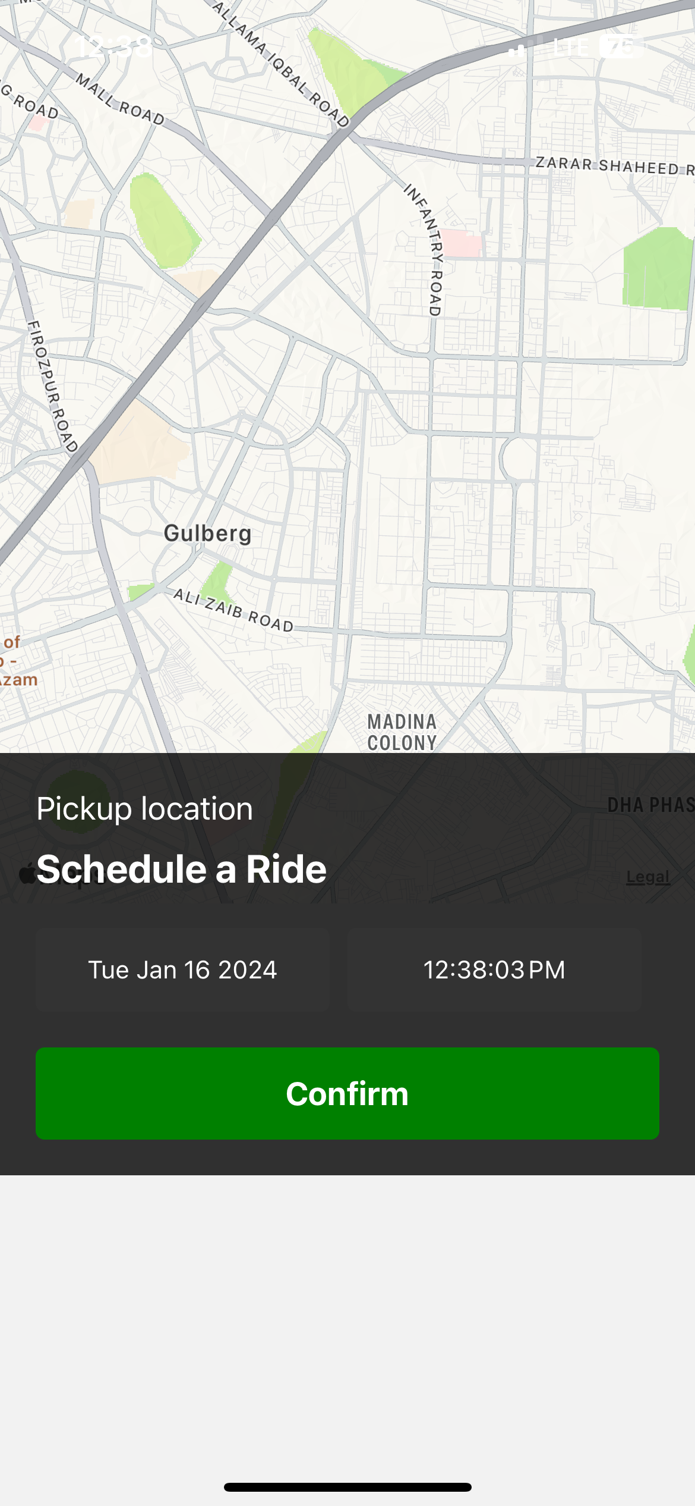

**6. Additional Features:**

Rating System:

Post-ride rating system enabling users to provide feedback on their experiences.

Facilitates quality control and continuous improvement.

Fare Estimates:

Pre-ride fare estimation feature providing users with cost transparency.

Helps users make informed decisions before confirming a ride.

Real-time Tracking:

Live tracking feature for users to monitor the real-time location of their booked rides.

Enhances user safety and provides accurate ETAs.

Customer Support:

Dedicated customer support section within the app for issue resolution.

Ensures users have a direct channel for problem-solving.

**7. Future Enhancements:**

Loyalty Program:

Implementation of a rewards system to incentivize and retain frequent users.

Encourages user loyalty and engagement.

Accessibility Features:

Ongoing efforts to enhance app accessibility for users with disabilities.

Demonstrates commitment to inclusivity and user diversity.

Expanded Service Areas:

Strategic expansion of service coverage to new regions and cities.

Broadens the user base and market reach.

**8. Technical Considerations:**

Security:

Implementation of robust security protocols for data protection.

Especially critical for secure processing of payment information.

Performance:

Ongoing optimization to ensure smooth app performance.

Ability to handle multiple simultaneous users without lag.

Scalability:

Backend architecture designed for scalability to accommodate growing user base and evolving feature sets.

Ensures long-term sustainability and adaptability.

**9. User Feedback and Iterations:**

Continuous user feedback collection through surveys, reviews, and in-app feedback mechanisms.

Regular iterations based on user suggestions to improve user experience.

**10. Marketing and User Acquisition:**

Strategic marketing campaigns including promotional offers, referral programs, and partnerships.

Aimed at attracting new users to the platform and fostering growth.  
  
  
**TEST CASES**  
  
**Test Case 1: Ride Booking and Navigation**

*Objective:* To ensure that users can successfully book a ride, view relevant details, and navigate to the destination.

* **Preconditions:**
  + User has a registered Cabify account.
  + The app is installed and updated to the latest version.
  + Location services and network connectivity are enabled on the user's device.
* **Test Steps:** a. Open the Cabify app and log in with valid credentials.

b. On the home screen, select the "Ride" option.

c. Choose the ride type (e.g., daily).

d. Enter the destination either by selecting from the preset list or using the search functionality.

e. Confirm the ride by selecting an available option on the map.

f. Verify that the app displays relevant ride details such as driver name, rating, estimated time of arrival (ETA), and fare.

g. Initiate the ride and ensure the real-time tracking functionality is accurate.

h. Observe and confirm that the navigation to the destination is provided and accurate.

* **Expected Result:**
  + The user should be able to successfully book a ride, view driver details, and navigate to the destination with accurate real-time tracking.
* **Pass Criteria:**
  + The ride is successfully booked.
  + Relevant details (driver name, rating, ETA, fare) are displayed.
  + Real-time tracking accurately reflects the driver's movement.
  + Navigation provides accurate directions to the destination.
* **Fail Criteria:**
  + Inability to book a ride.
  + Incorrect or missing details during the booking process.
  + Real-time tracking inaccuracies.
  + Navigation directions are incorrect or lead to the wrong destination.

**Test Case 2: Car Rental and Payment**

*Objective:* To validate the process of renting a car, selecting payment methods, and ensuring the payment transaction is secure.

* **Preconditions:**
  + User has a registered Cabify account.
  + The app is installed and updated to the latest version.
  + Location services and network connectivity are enabled on the user's device.
  + Sufficient funds or a valid payment method is available.
* **Test Steps:** a. Open the Cabify app and log in with valid credentials.

b. Navigate to the "Rent" section of the app.

c. Browse the available cars, select a preferred model based on preference and budget.

d. Review the car details including images, model name, and rental price.

e. Confirm the rental and proceed to the payment screen.

f. Select a payment method (e.g., credit card) and enter the required details securely.

g. Verify that the payment transaction is processed successfully.

h. Check for a confirmation screen displaying rental details and payment confirmation.

* **Expected Result:**
  + The user should be able to successfully rent a car, choose a payment method, and complete the payment transaction securely.
* **Pass Criteria:**
  + Car rental is successfully initiated.
  + Car details and rental price are accurately displayed.
  + Payment method selection is smooth and secure.
  + The payment transaction is processed successfully.
  + A confirmation screen with rental details and payment confirmation is presented.
* **Fail Criteria:**
  + Inability to initiate car rental.
  + Errors or inaccuracies in displayed car details or rental pricing.
  + Payment method selection failure.
  + Payment transaction is unsuccessful.
  + Lack of confirmation or errors in the confirmation screen.